**Scope**

This custom GS Mobile transactions will be used to receive a Walmart shelf part into inventory for refurbishment. The transaction will process through as a stand-alone receipt (A10). A label will print and inventory and item master will be updated accordingly.

**Installation**

1. Requires GSS version 2015.1 or later with all hotfixes applied.
2. Unzip GAB_Mobile_Walmart_MorganLi.zip to global\plugins\gab\gas
3. Save IV_Issue_Receipt_Trans_PLA.lab to global\busint\labels folder
   1. Make a copy of label for each company code and replace PLA with 3 digit company code in label file name.
4. Create new custom mobile transaction (advanced GS mobile options > Custom)
   1. take note of transaction id number (1-5)
   2. name "Walmart Receipt"
   3. Add the following fields on web form as text box
      1. Part
      2. Store
      3. 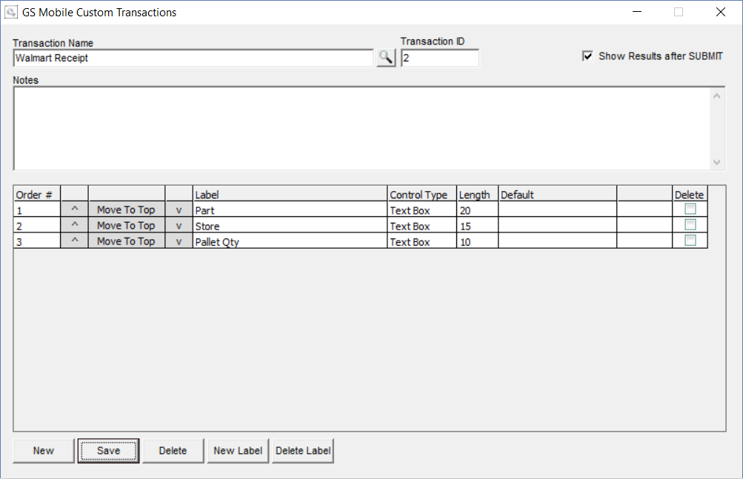Pallet Qty
   4. check box to "show results after SUBMIT"
   5. save
5. Activate GAB hook (system support > administration > gab script hook maintenance)
   1. if custom transaction id is 1 then GAB hook to activate is 39001, if it is 2 then hook is 39002 and so forth…
   2. Enter hook id then select to <Add Seq>, browse for global\plugins\gab\gas\ GAB_Mobile_TransformerReceipt_Alamo.gas, Save Seq, Save Hook.
   3. Activate same script for hook ***31908***
   4. Stop and restart wirepoll.exe
6. Grant mobile user access to the new custom transaction (system support > administration > GS mobile users > open)

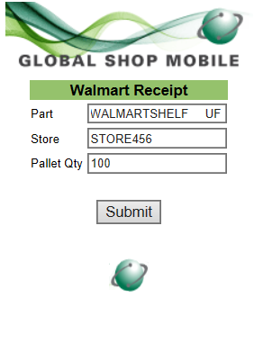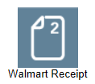

**Using Transaction**

1. Fill in form
   1. Part
   2. Store
   3. Pallet Qty
2. Lot : auto assigned next lot based on adv inventory auto lot numbering
3. Bin: set to RECV
4. If PART/REV/LOC validate to inventory master then write a stand-alone receipt transaction (A10) to wireless tables
   1. New WIR200 hook 31908 will execute GAB script to update item_master user fields from input data in form
   2. Print stand-alone receipt label (CodeSoft)

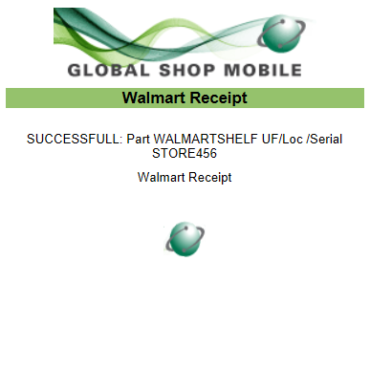

**Return Results Page**

* Every transaction will be validated with a message stating transaction was ***SUCCESSFUL*** or ***FAILED*** and why it failed.

**Label**

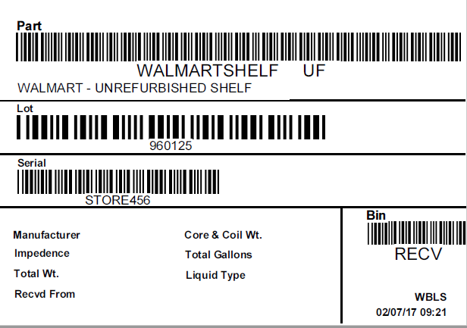

**Inventory updated and new LOT/bin record created**

